Exercise 3 - Consensus Reconstruction
1. Perform a tree reconstruction using Belvu for each individual alignment.
1.1. Obtain 10 different trees, one for each ortholog cluster, in Newick format.

Tree 0
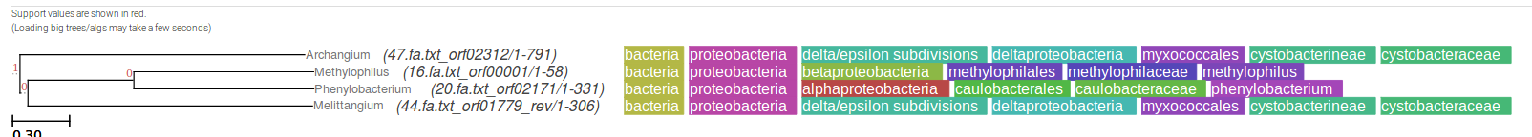
Tree 1
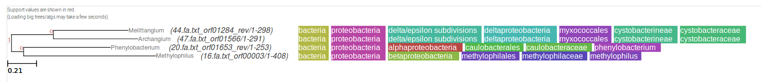
Tree 2
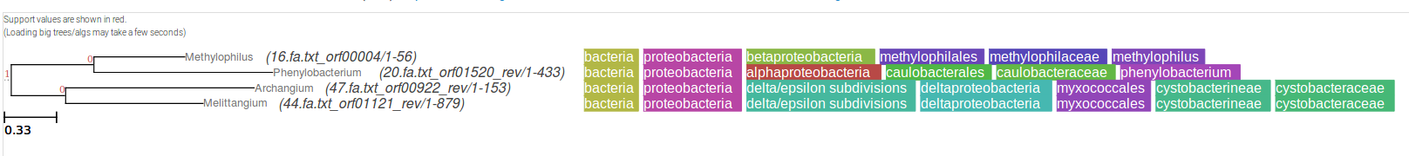
Tree 3
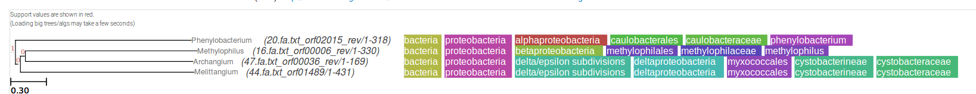
Tree 4
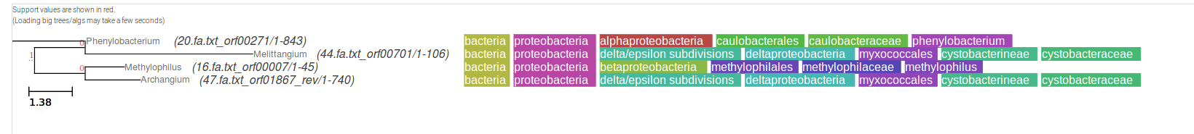
Tree 5
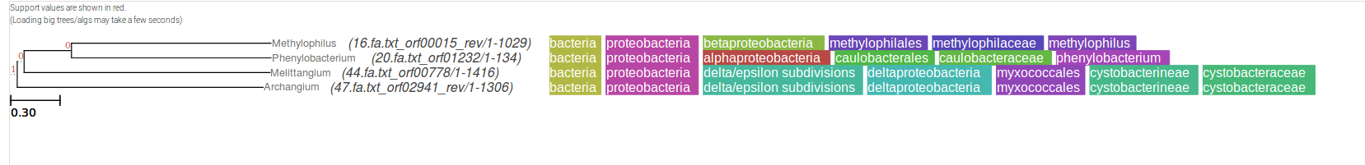
Tree 6
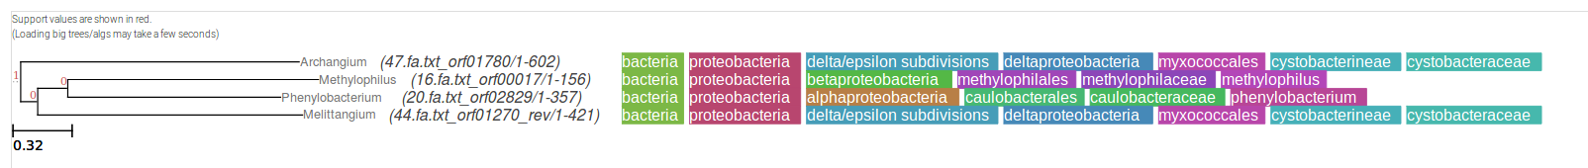
Tree 7
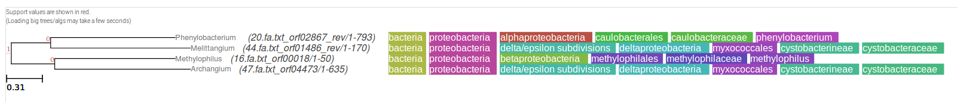

Tree 8
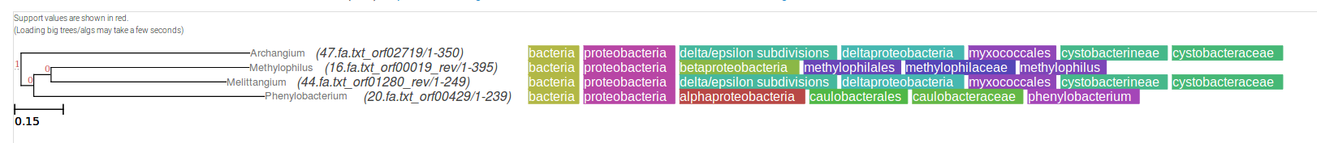
Tree 9
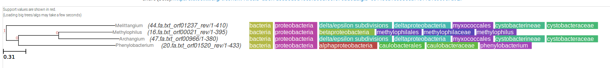
1.2. How precise are those trees? Discuss.

It’s not prudent to discuss the accuracy of these trees from a single alignment, a bootstrap has to be done to assess the precision.

1.3. Point a few specific genes or classes of the genes that cause disagreement.

Tree 4, 20.fa.txt_orf0027.

1.4. Discuss the reasons of this disagreement.

Tree 4 in particular, with the gene 20.fa.txt_orf0027, disagrees with the rest of the tree. The evolutionary distance of this particular gene is going further back in time, even before the rest of the genes branch. This could be due to an error in the tree format.

Additionally, the ten different trees will definitely disagree because the orthologue clusters contain different genes to begin with, therefore resulting in completely different trees, although some trees may share similarities due to the genes coming overall from the same organisms.

2. Construct a consensus tree from the gene trees using Phylip example. For combining the tree, it is important that you use the species names as protein identifier in each tree.
2.1. Use Phylip consense to construct a consensus tree;
2.1.1. Put the tree files together into a file containing a list of the trees.
2.1.2. Name this file intree.
2.1.3. Phylip will read the file named intree in the present directory, ask you a few questions. Describe this process.

First the individual trees produced with Belvu were combined using the cat command, to produce a single tree file for all ten trees. Some formatting was necessary to ensure that PHYLIP was able to read the file; ie., the species names were formatted from FASTA format to this format instead (44:0.556). The resulting file was called infile, and PHYLIP asked a few questions about the consensus options:

C Consensus type (MRe, strict, MR, Ml): Majority rule (extended)
O Outgroup root: No, use as outgroup species 1
R Trees to be treated as Rooted: No
T Terminal type (IBM PC, ANSI, none): ANSI
1 Print out the sets of species: Yes
2 Print indications of progress of run: Yes
3 Print out tree: Yes
4 Write out trees onto tree file: Yes

The resulting tree file was viewed using the ETE toolkit.
